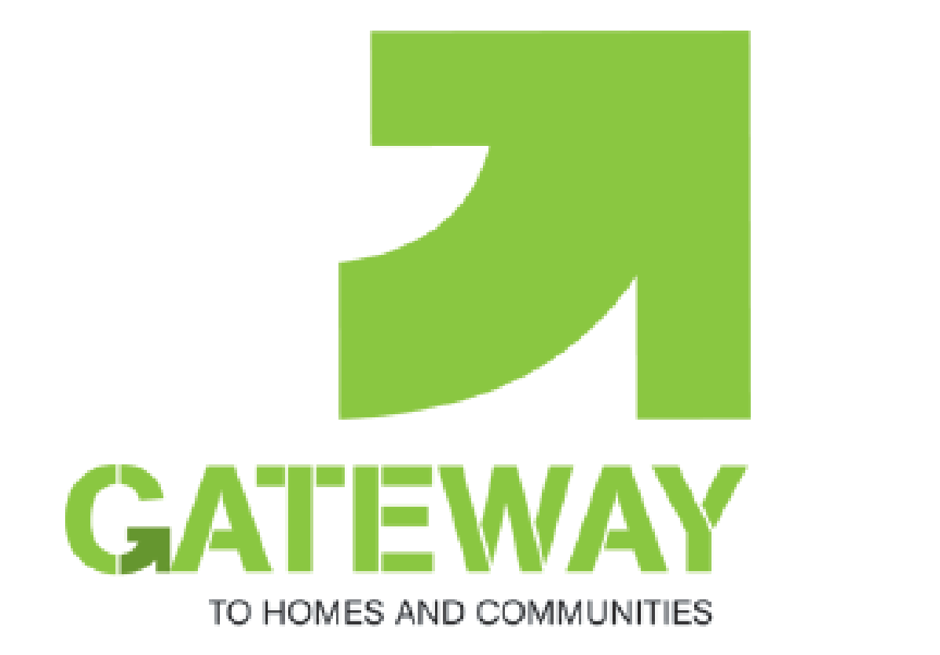

**Gateway to Homes and Communities**

**Referral Form**

|  |  |  |  |  |  |  |
| --- | --- | --- | --- | --- | --- | --- |
| **Client Details** | | | | | | |
| **Name** | |  | | | | |
| **Date of Birth** | |  | | | | |
| **Address** | |  | | | | |
| **Post Code** | |  | | | | |
| **Telephone** | |  | | | | |
| **Landlord** | |  | | | | |
| **Tenancy Type** | |  | | | | |
| **Referrer Details** | | | | | | |
| **Name** | |  | | | | |
| **Agency** | |  | | | | |
| **Telephone** | |  | | | | |
| **Email** | |  | | | | |
|  | |  | | | | |
| **Please indicate which of the following items are required:** | | | | | **Please indicate how many of the following starter packs are required:** | |
| Bed (*Single or Double*) | | |  | | Crockery/Cutlery |  |
| Seating (*Armchair or Sofa*) | | |  | | Pots, Pans, Utensils |  |
| Microwave | | |  | | Cleaning Products |  |
| Fridge (*table top*) | | |  | | Single Bedding |  |
|  | | |  | | Double Bedding |  |
|  | **Please tick this box if you have spoken with your client and they are happy to be contacted directly by Gateway to Homes and Communities as part of our client feedback process.** | | |  | Towels |  |
|  | Curtains |  |
|  | Small Electricals |  |
|  | Toiletries |  |
|  | Food |  |

Your client may be eligible for to apply to the Scottish Welfare Fund which is a discretionary scheme and each application will be considered according to the individual circumstances of the case.

You or your client can apply on 0131 529 5299 or at [www.edinburgh.gov.uk/scottishwelfarefund](http://www.edinburgh.gov.uk/scottishwelfarefund)

|  |
| --- |
| Once completed, please email this form to [gateway@bethanychristiantrust.com](mailto:gateway@bethanychristiantrust.com). You will receive an automatic reply, and then you may call on 0131 561 8903 to arrange delivery and onward referral to all aspects of the service. |

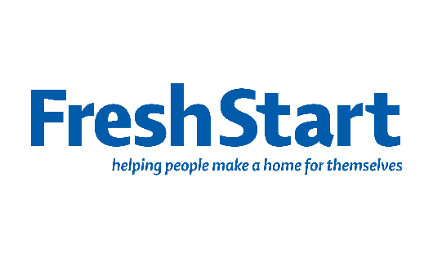

As part of providing a service, Bethany Christian Trust are committed to ensuring that your personal data is processed lawfully, fairly and securely. We won't share your information with other organisations unless you have specifically consented for us to do so or when we are required to comply with other organisations by law.

We will keep your personal data for the period of your involvement with the service and then for a further ten years in keeping with regulation. After this time it will be securely destroyed if it is no longer required for the purpose for which it was gathered in the first instance. For people using our services who are under the age of 18 their information will be held indefinitely in response to the **Limitation (Childhood Abuse) (Scotland) Act 2017**.

You have the right to request access to your personal data which is held by us and to change and update those details. This request can be made through a member of the service’s staff or management.

Our Fair Processing Notice is available from our website [www.bethanychristiantrust.com](http://www.bethanychristiantrust.com) . If you have any further concerns about how your personal information is handled and processed by us then please contact our Data Protection Lead, based at the address of the Data Controller which is Bethany Christian Trust, 65 Bonnington Road, Edinburgh, EH6 5JQ or via [dpl@bethanychristiantrust.com](mailto:dpl@bethanychristiantrust.com) or 0131 561 8930 and we will attempt to resolve any issues you have. If you remain unsatisfied you have the right to lodge a complaint with the Information Commissioner’s Office <https://ico.org.uk/>

**FOR GATEWAY OFFICE USE ONLY**

|  |  |  |  |  |
| --- | --- | --- | --- | --- |
| Date of referral |  |  |  |  |
| Date of delivery |  |  |  |  |
| Hub informed |  |  |  |  |
| Customer number |  |  |  |  |